they have bitbucket connection which are external to dataiku and that imported in to our dataiku, all this connections already created by the admins so we are able access all this libraries in dataiku.

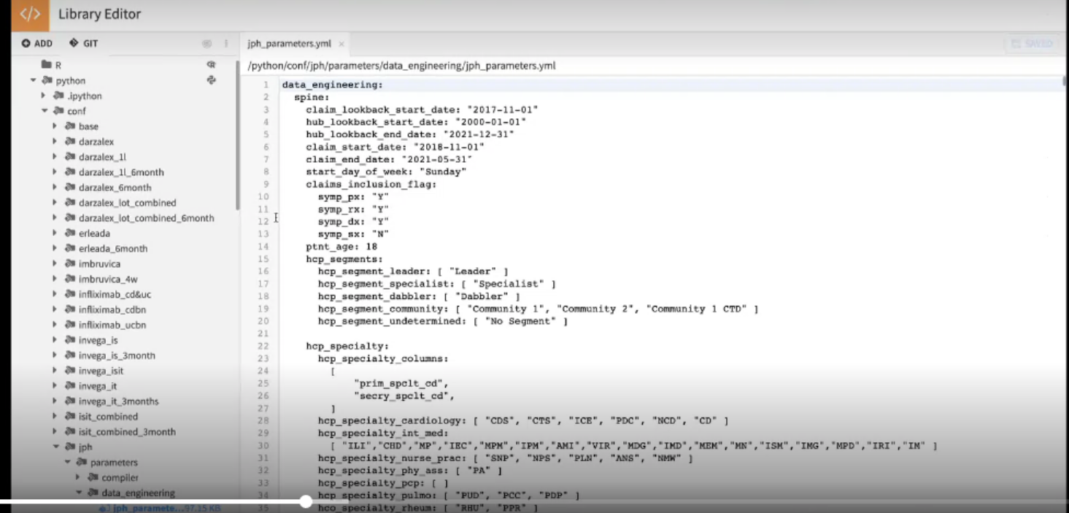

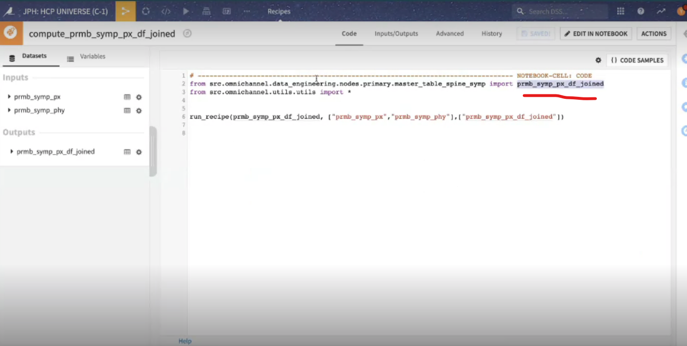

Lets take pyspark receipe where we have some recipe code not from the external source if u make any changes in to that recipe this all can be maintained in dataiku DSS it self.

Let take pyspark spark recipe and I have upated with some comment (#)

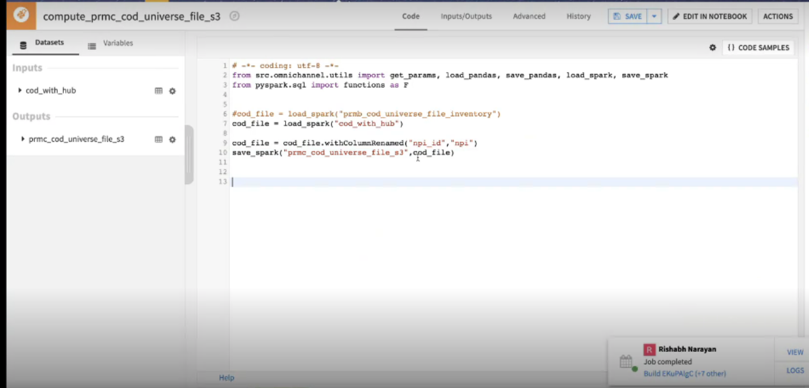

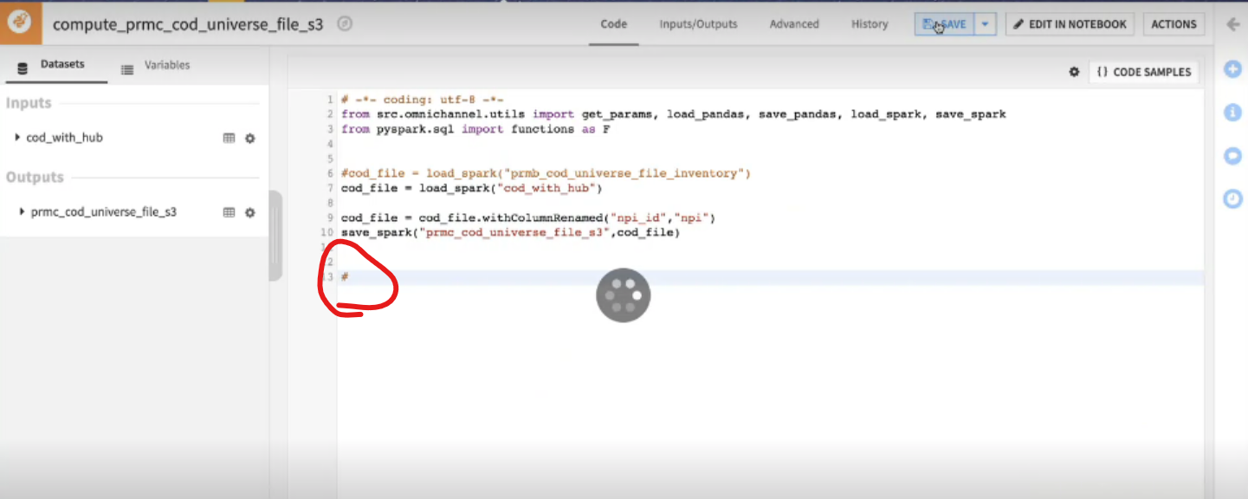A

All this changes are maintained by DataIKU itself

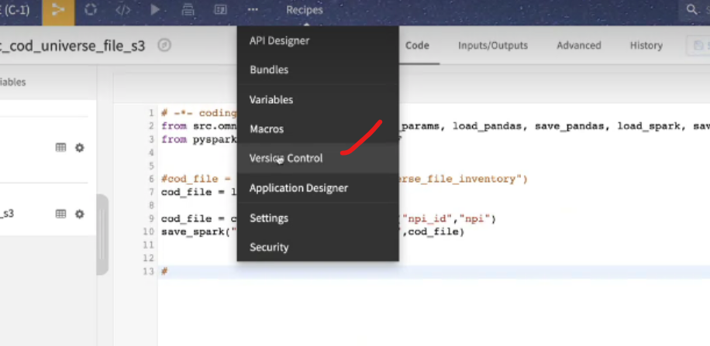

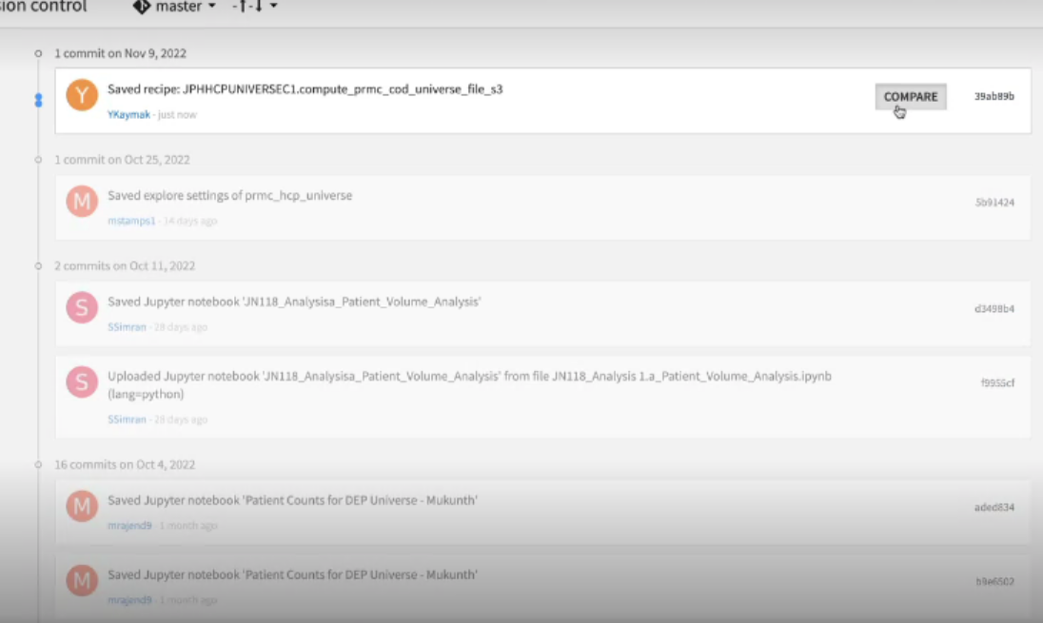

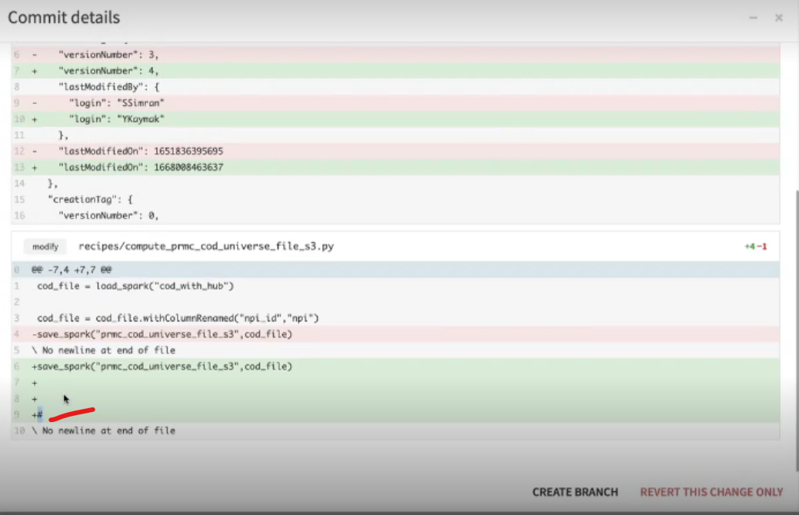

This are saved in json file that are maintained by Dataiku and controlled by Dataiku and we don’t have access for that

Right now Cap team have to do is , if I click on revert this change only I should be able to go back to the previous version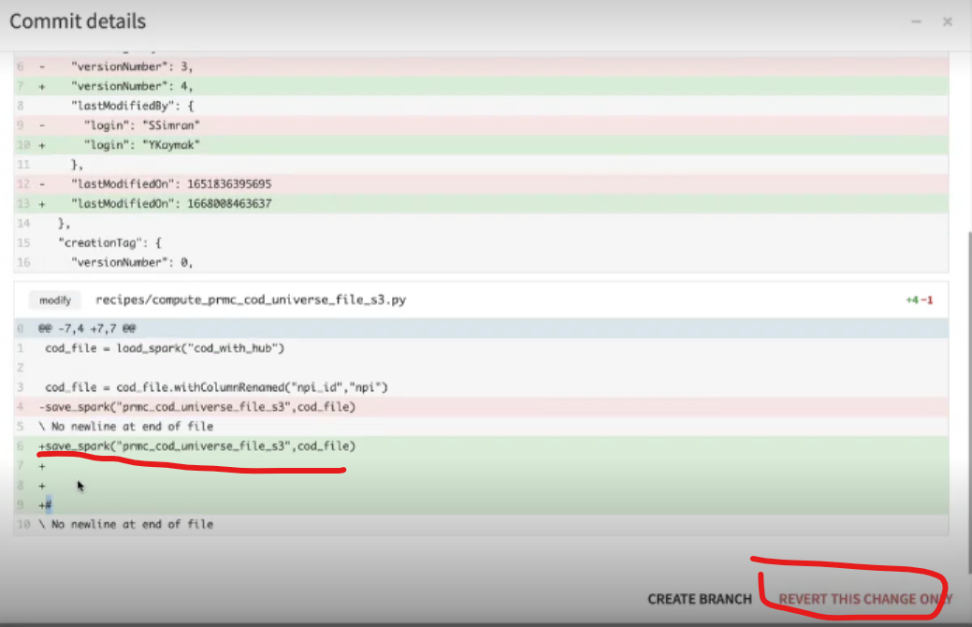

Suppose the updated chages are not working properly I should be able rollback to previous version with out bundling everything